Report – Grand Chennai Open Athletic Meet 2015
14th and 15th November 2015
Jawaharlal Nehru Stadium, Chennai
Brahma Kumaris, Chennai organized a Grand Chennai open athletic meet on 14 & 15th of November 2015 at Jawaharlal Nehru Stadium. More than 2000 athletes from 85 schools/colleges/clubs participated in the midst of heavy rain in Chennai.
On 14th November 7.30 am, the athletic meet was inaugurated by Dr. A.M. Moorthy, Vice chancellor of Tamil nadu Physical education and sports university and Mr. Elangovan, HOD, Dept. of Yoga, Tamil nadu Physical education and sports university in the presence of Rajayogini B. K. Kalavathyji, Senior Rajayoga Teacher and B.K. Devi, Programme co-ordinator. The inauguration started with the hoisting of National flag and God father Shiva’s Flag, continued with March past, Olympic Torch and colorful balloon release.

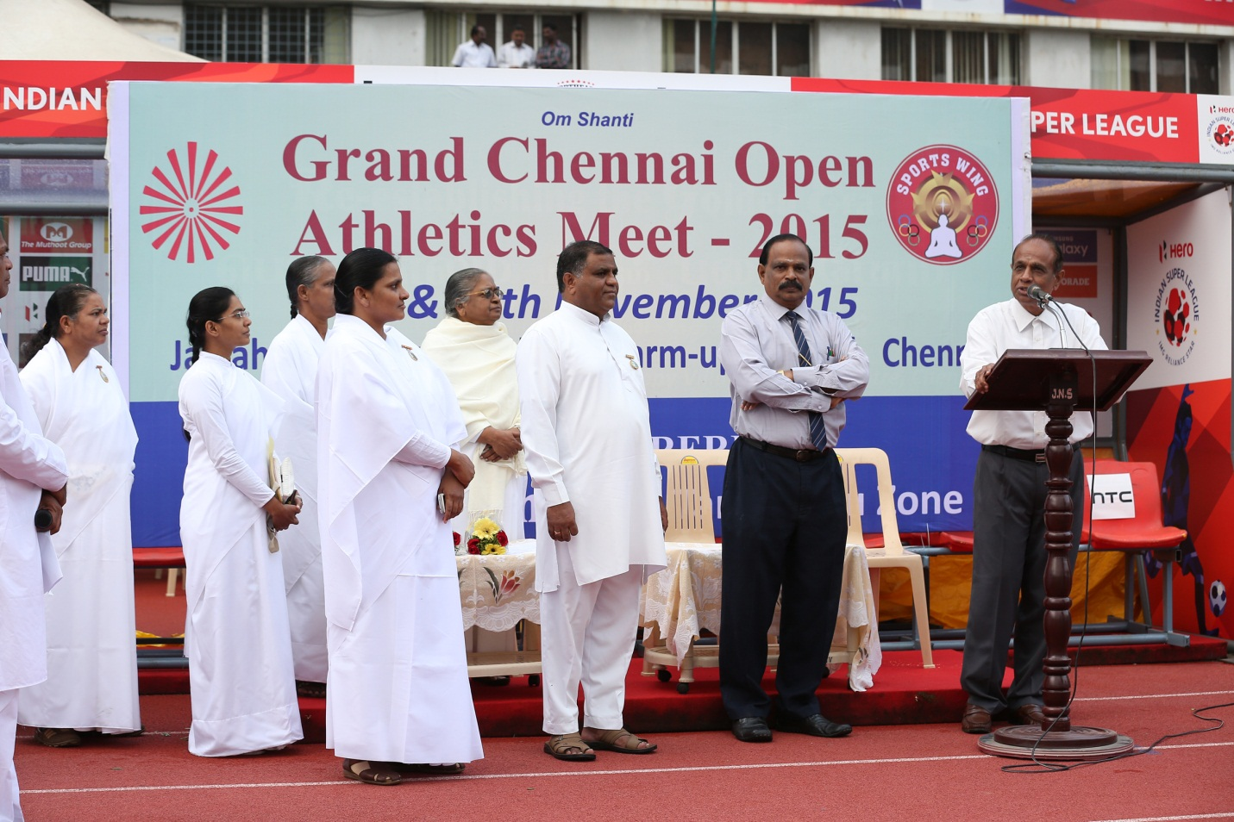

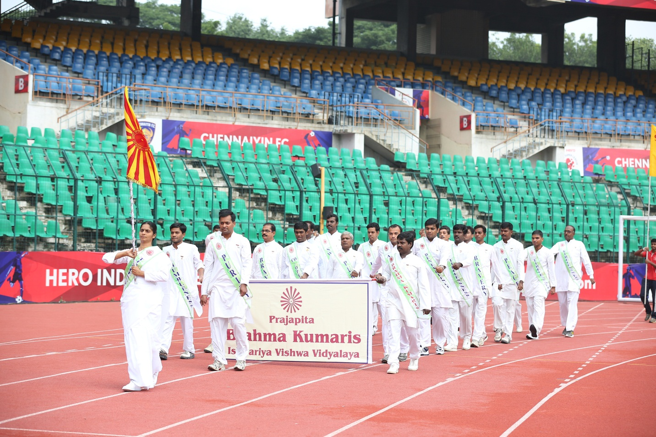

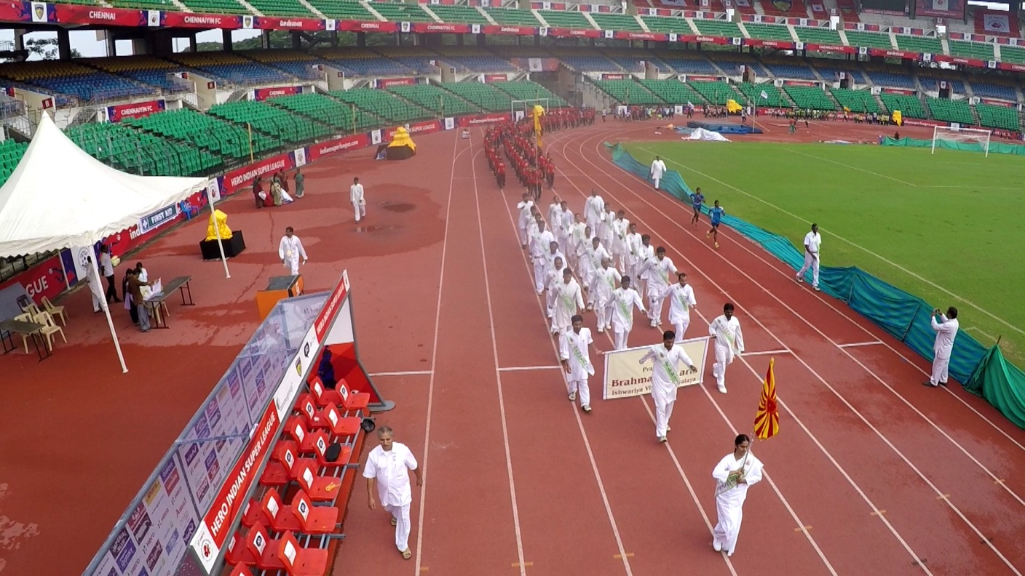
All the 2 day different events like 100m/200m/ 400m/ 800m/ 1500m dash, Hurdles, Long Jump, High Jump, Javelin Throw, Shot put and Relay race took place for boys and girls of 3 age categories - Under 20, Under 18 and Under 16. Many athletes participated with more zeal and enthusiasm.
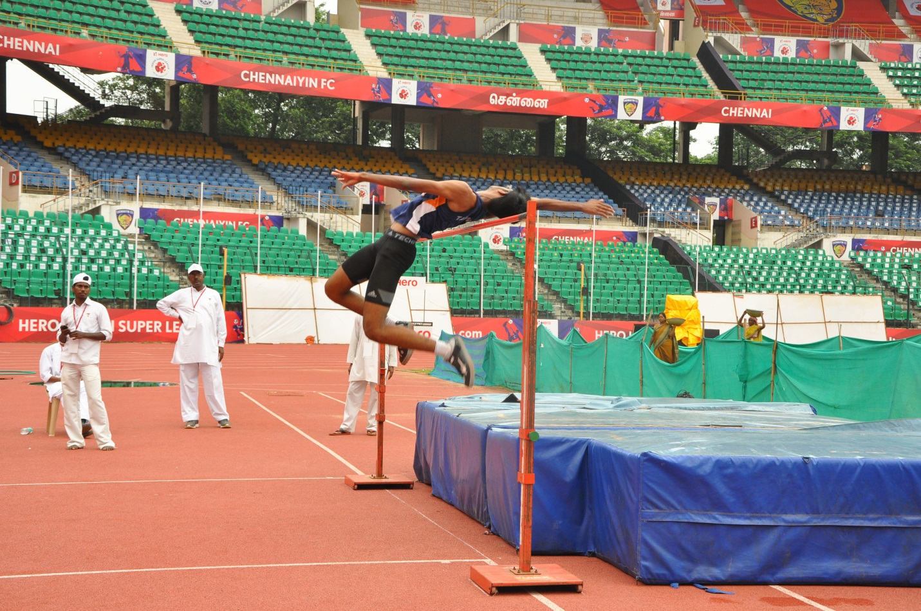
Other than athletic events, Rajayoga pictorial exhibition stall, Rajayoga meditation Room and Value tree was arranged for the athletes and their parents.
All the winners were honored by crowns on the Victory Stand. The medals and trophies will be awarded to the winners in the forthcoming National level Sports conference at Happy Village, Brahma Kumaris Retreat Centre next to Chennai on 6th December 2015.

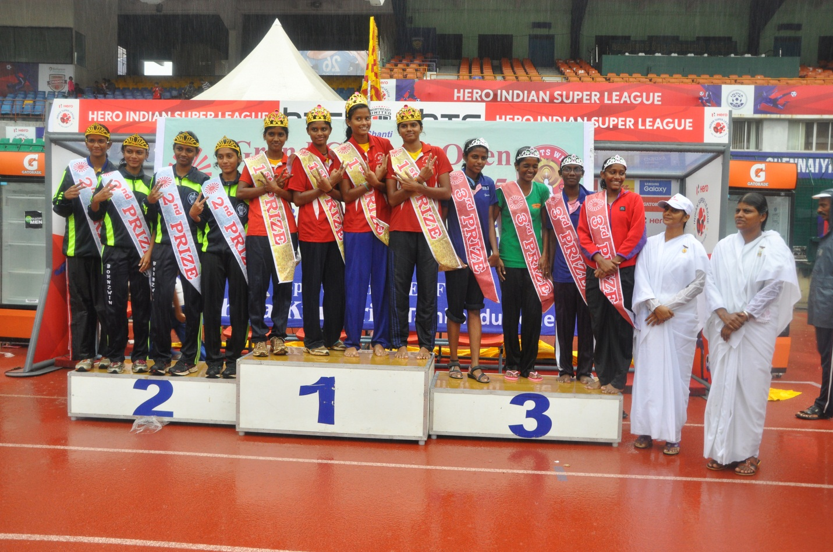
It was a nice opportunity to Meet many sports person and reach them and serve them spiritually.

