DR. BINNY RECEIVED HONOUR OF MEETING HER EXCELLENCY SMT. PRATIBHA PATIL, PRESIDENT OF INDIA AT RASHTRAPATI BHAVAN
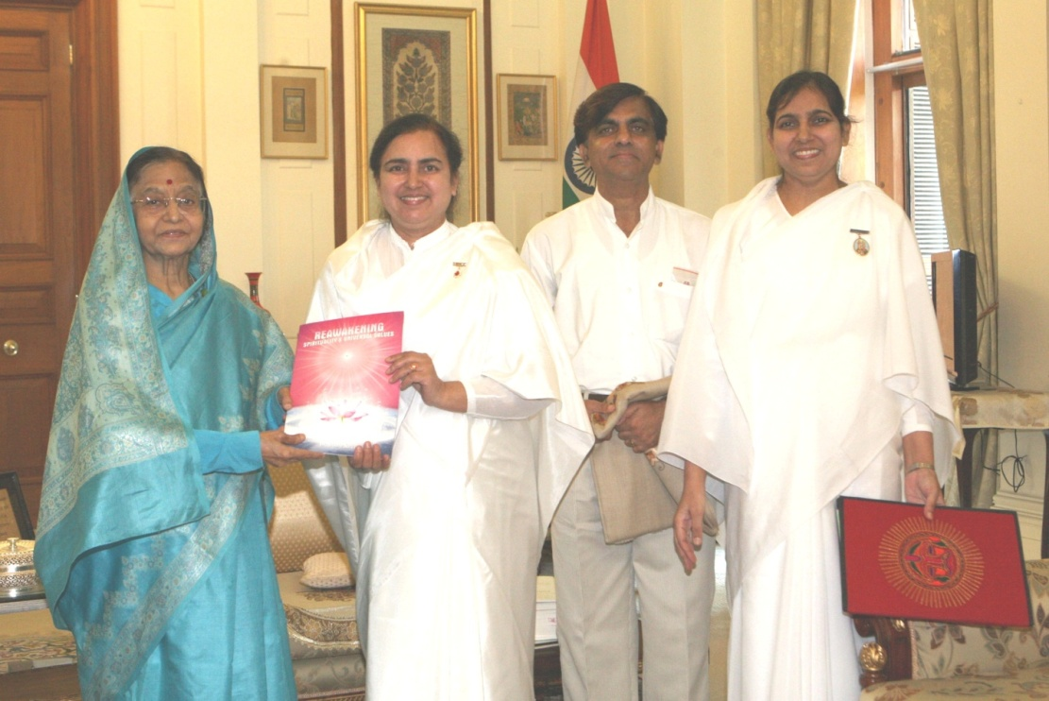
Dr. BK Binny of Global Hospital Mount Abu is presenting essence of her doctorate thesis on the subject “Brahma Kumaris’ contribution in Reawakening Spirituality and Universal Values” to the President along with B.K Rakesh & B.K. Neena
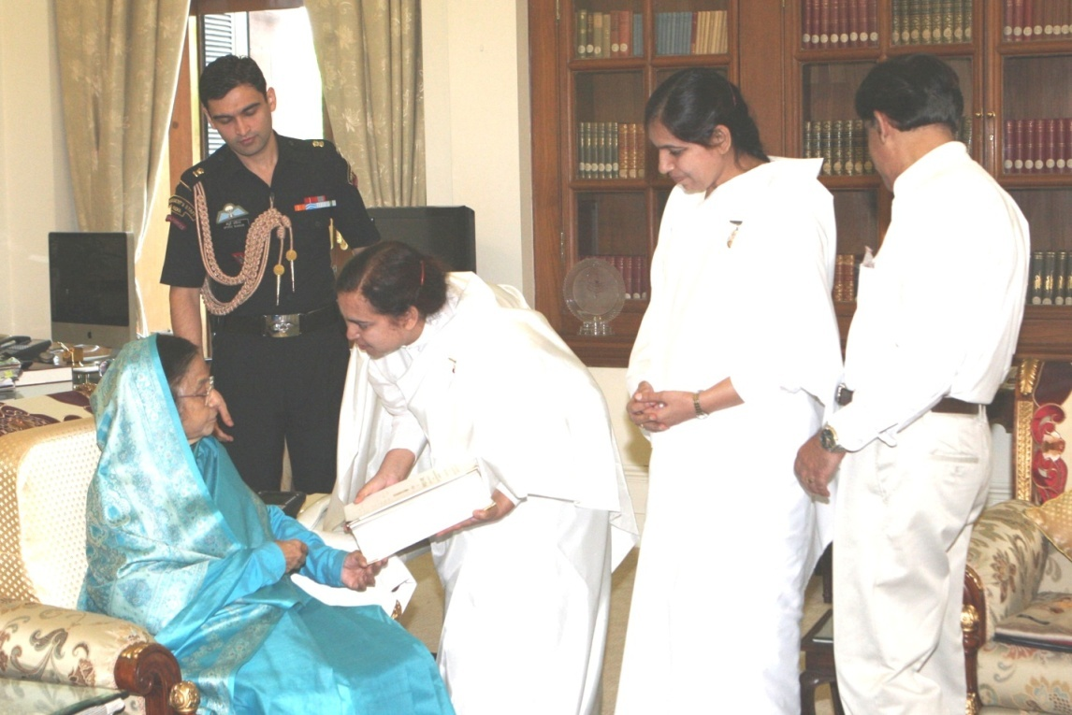
Dr. B.K. Binny is showing awarded doctorate thesis to the President

