SISTER JAYANTI OF BK BLESSES THE PHILIPPINES

By Vishnu Hathiramani www.sindhitattler.com

Blessings come in many forms.

This week we were truly blessed. A week where the Sindhi community of the Philippines had the opportunity to hear our dearest SINDHI sister JAYANTI KRIPALANI of the Brahma Kumari [BK] mission( Brahma Kumaris World Spiritual University Philippine Foundation) in several programs . Each time we experience powerful vibrations, great inspiration), a feeling that life can be greater than we expected or simply put: we were blessed.

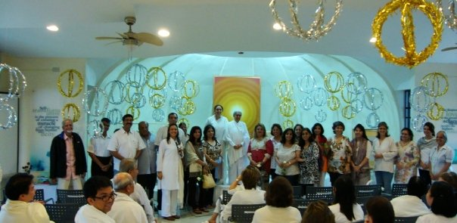

Read on……………………………….

Indian Ambassador to the Philippines His Excellency Rajeet Mitter and his wife Kavita hosted a welcome get together for the BK guests and special friendson Wednesday , 2nd of September at his residence. Invited were a select crowd from the Indian community, key Filipino government officials and other prominent Filipino nationals. The atmosphere at the reception was one of warmth and friendship. Sister Jayanti shared the various programs that the Brahma Kumaris has been undertaking worldwide.

On September 3, at the newly renovated Main Ballroom [which cost close to US$ 3 Million to have it refurbished by the Shangri-La Hotel group], more than 1400 persons attended the BK program entitled : “ The silence of the Mind”. It was expected that 80% of the crowd would be Filipinos but for those who came for the first time, it was a shocker. There has never been a time that more than a 1000 Filipinos show up, and that too a religious function.( No need to say this) or we can say. The program drew many first timers who were attracted by the creative topic. Some prominent people that attended include the Secretary of Education, key officials from the of Justice, Department of Natural Resources and Environment, civil Service Commision, National Nutrition Council, among others.

Brahma Kumaris has been in existence in the Philippines over the past 27 years and has been known for its values, raja yoga meditation and character building programs. It has been providing seminar /workshops and talks on various topics like positive thinking, stress management, spirituality, transformative and ethical leadership to various audiences.

But wait, I need to clarify this statement of mine. BK is not a religious organization but a centre of Meditation. It has no national or religious boundaries. It is a need of the humanity, more so with the present state of the human mind. We too have to get away from the financial cloud surrounding the world, the daily tensions of life and the fact that stress has become a major killer.( no need to put this)

September 4, Friday, a day where traffic is the heaviest, the overseas BK delegation motored to Tagaytay, a 2-hour drive from Manila. It is in this mountainous area where the famous TAAL volcano is located and where the air is clean and fresh ( as the world air was 100 years ago, and where tension can easily disappear meets relaxation, and gives up.)
A silence retreat was held at the BK’s Center for Spiritual Learning , facilitated by Sister Rajnibhen and Sister Salud , and Beena Gurnamal Bharwaney, who did most of the arrangements. A lot of coordination and planning took place to ensure success of the retreat.

Around 200 Brahma Kumaris students and members form all over the Philippines attended the program. From the Indian community, Beena Gurnamal Bharwaney of HK and Manila., Arjan and Menu Melwani of HK among others attended . They have everything that would make anyone proud, yet they are humble. Their stamina has driven away the word “OLD” from their lives. They could be a perfect example of a successful ad of “CHARAN PRAS”, the Indian herb medical based Pharma item that claims it makes you look young if you are old

On Saturday the 5th the centre was prepared to receive the Sindhis who were scheduled to go down there. Be it your car or the sponsored bus, all were excited. Those on the bus had a chance to listen to Sister Shivani of BK on the video and 2 Sindhi tele films. White roses and smiles received them, a hour of blessed speech by our dearest Sister Jayanti bought us back in that period of time when our thoughts were clear and unbiased, our actions better than now and we got a “ping” [learned this word from my blackberry] from the speech that we must revert back to our old selves. Indeed this is her magical power to let us understand our weaknesses. I felt it.

Various activities marked the day. An excellent song rendition by London based GIRISH WADHWANI has put this gentleman on our life-long personal directory listing. BK Filipinos showed their creative talents through their songs and dances. Surprise talents ROMA MUKHI and TRILOK DOWLANI of the Philippines performances will now give them a life time request: please sing at every occasion.

Hunger too has a part in our daily life. The cold weather, with the drops of rain on the windows, a dark cloudy day, gave us a hunger more than required. The fresh green salad did wonders. It is a secret which I share: The centre plants its own vegetables too. The mint-based “sana” pakoras [we are Sindhis, after all!] and the mint chutney could not be better, it was the best. The unpolished brown rice, the puris, the mixed vegetables, the large varieties of vegetarian food, and the delicious boiled corn left us with memories and a desire to go back to them soon. Hey, I forgot the LECHE FLAN, a milk-based Spanish desert.

Back to another location: the UNITY ROOM. A one hour inspiration talk by MEELU WADHWANI of London and wife of Girish] could put many speakers and talk shows to shame. She is the greatest. Easy to understand, with sprinkles of SINDHI words, practical SINDHI way of life which was the centre of her speech, gave us what we have forgotten. Life is what we make it. Meelu [I hope I got your spelling right] deserves to speak to the SINDHI world. I would encourage that she be invited to your country whenever Dadi Janki or Sister Jayanti travels, for her power of reminding us what we have forgotten. 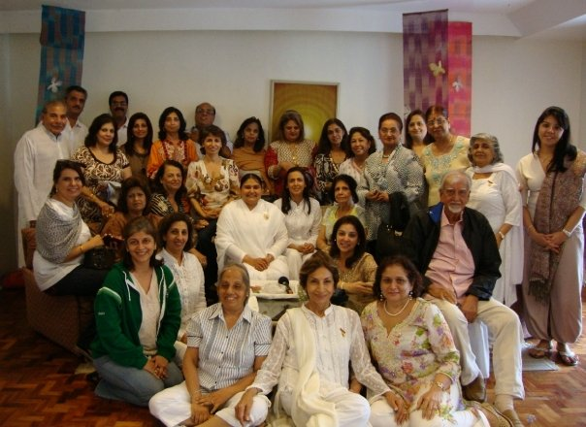

Another sister of BK, from New Zealand, Sister BHAVNA SHUKLA [yep a Gujarati], gave us her insights and spoke of some interesting things. Her tale that when BK was being established in NZ, the Immigration asked her if they perform weddings. Shockingly, she told the Immigration department that they do perform weddings. The audience was confused that how could BK performs marriages. She clarified that BK does SPIRITUAL MARRIAGES. A great joke that gave her the initial approval. When asked how the divorce rate in these marriages is, she said that it is zero. Once you get hooked on to meditation and realize its value, there is no divorce. This earned her and BK the signature of the Immigration guy to operate BK in NZ.

The piping hot tea, the delicious centre-baked cookies and the imported chiwro from India capped the day’s activities for those who had to return back to Manila and reality of life. And a enlightening visit to the room of Dadaji where silence is at its highest. Blessings were in abundance.

Those who stayed behind were more blessed than us. Their one night stay, sponsored by the BK centre, made them more special than most of us. [A report by Sujata Mukhi will follow soon]

A special youth session was organized by the wonderful Tolani family, Raju and Shilpa, on Sunday the 6th of September from 5 to 7 pm, at their residence. Another impressive thoughts and speech by Meelu Wadhwani of London. Great just great.

BK is more than I expected, more than you have heard about and definitely a future date for us all. ( Explain this please, not very clear)
Here are those who attended:
Chugani Shanti, Daryanani Gopi H, Dhanwani Duru, Dowlani Trilok, Gurnamal Nirmala and Angelie, Hathiramani Manisha, Hathiramani Vishnu and Heena, Hemandas Thakuri, Jeswani Kamla, Maker Anil and Rita, Mukhi Sunder and Sujata, Mukhi Roma, Mirani Priya, Mirpuri Duru, Mirpuri Roshni, Sehwani Dolly, Tolani Shilpa, Uttam Raju, Vaswani Ram and Heeru, Manohar and Shakuntala. [Sorry if some names are omitted].
Indeed it was a great show. Our Congratulations.
Some highlights:
- Those who came in the chartered bus had a great opportunity to listen to Sister Shivani speak on Ego. This was followed by two short SINDHI movies, which have been produced by ASHA CHAND of DUBAI.
- It was truly a family affair. The warmth extended by the BK family, Filipinos brothers and sisters, was amazing.
- The crowd at Hotel Shangri-La had the crème of the crème of the Filipino community. Actor Robin Padilla, devotee and Philippines Comedienne par excellence Tessie Tomas, Senator Leticia Shahani, and others present must have been truly impressed with the set up. Three big video screens gave everyone, wherever seated a clear picture of Sister Jayanti and her speech. Others names are mentioned in the article below. Please read.
Copyright by Vishnu Hathiramani, Manila, Philippines. Log on to www.sindhitattler.com and www.rpindia.info for more info. Article may be posted or reprinted provided acknowledgment is given.

We hereby are uploading this article as written by Brahma Kumari Philippine Foundation
during Sister Jayanti's Public Program which was held in Manila on 3 September 2009

LESS than a half hour into the talk, Sister Jayanti took her audience on a brief quieting experience that aptly illustrated the evening's subject, "The Silence of the Mind."
The newly refurbished Rizal Ballroom of the five-star Makati Shangri-La Hotel in the country's business capital fell into such a hush, that the audience-said "Yes," they understood the point of the exercise, when Jayantibhen asked, "Do you think it is possible to go to that sacred place, then come back to the physical realm, still holding the peace in my heart?"
At last Thursday's event, people were still streaming in almost an hour after the speaker took her seat on the tastefully decked stage with a huge video screen on the center wall and two slightly smaller ones on either side.
"Silence hasn't had a good press," Sister Jayanti jested. "For many, the very word conjures loneliness, nothingness, the end of communication." The next statement brought a smile to the faces of her listeners: "In truth, silence doesn't come from making my mind blank. It is a stage of fullness in which there is peace, wisdom, love, purity and joy."
She posed a riddle: "Did you ever imagine silence and joy being connected?"
This certainly struck home for Filipinos, who are known for being drawn to religion and merriment in equal parts.
*Chairs, quick!*
Close to 1400 people, various sectors were represented. To name a few, the diplomatic circle from the British Embassy and India Embassy, key leaders from the government such as the Secretary of the Department of Education, undersecretaries and assistant secretaries from the Department of Trade and Industry, Department of Justice, Department of Environment and Natural Resources, Department of Labor and Employment, commissioner of the Civil Service Commission, lead convener of the Philippine Council of Islam and Democracy, and managers of Home Development Mutual Fund. Catholic Church leader Bishop Yniguez, and president of the Ramon Magsaysay Award Foundation (equivalent of Nobel Prize in Asia) also attended. Even educational institutions from distant places also attended. A good number also came from professional groups like Philippine Association of Secretaries & Administrative Professionals and Young Women's Christian Association as well as
business sector like Design Coordinates, Inc. who endorsed the program to their members, managers and staff. The reception desk for walk-ins was as busy as for those who had pre-registered. Additional chairs were being carried in almost throughout the program.
In any case, even those who had come in the latest caught precious bits:
"Peace has two faces: one is to experience it for myself; the other is to express it with a life of peace through my actions."
"Tonight is not just about hearing a talk to make us feel good for a day; tonight should be about generating energy to make things-within ourselves and all around us-move in the right direction."
"True silence, and true change, is possible only by connecting with the One above. And since, being a spirit, He does not have a body of His own; we should be His hands and feet."
An obvious crowd pleaser was Sister Jayanti's comparison of man's relationship with God as that of child and parent:
"Sometimes, even without consciously connecting with Him, you still feel His guidance and Protection. That's because whatever the child has become, whatever the child has done, the parent is still bound to always extending a hand."
One of the celebrity guests was a television and big-screen superstar who is also among the top three product endorsers in the country. A Muslim, he had rushed to the program right after his Ramadan fast. Still, he was very alert throughout the talk and, at the end of the evening, came away looking fresh and sprightly, greeting everyone wearing white, "Om shanti, Om shanti!"
Then turning serious, he asked a BK sister, "Does Sister Jayanti have a book? How about recorded lectures? Is she coming back soon?" And then, as though suddenly taken over by inspiration, "Who is her teacher?"
In essence, "The Silence of the Mind" program was a unique experience of a spiritual conversation with deep experiences of silence within.
End of article. Om Shanti.

